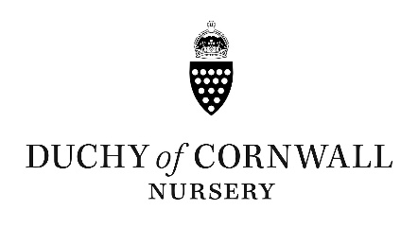
Mothering Sunday Weekend - 29/30th March 2025
Brunch Menu £28pp

Welcome Drink
Peach Bellini / Matcha Ginger Sour / Raspberry Gin Iced Tea

Duchy eggs royale
Two poached organic eggs, smoked salmon & hollandaise sauce on a sourdough English muffin, Duchy thyme fried potatoes

Chorizo tortilla
Classic Spanish omelette with chorizo, Duchy poached egg, red pepper sauce & watercress salad GF/DF

Steak & eggs
Seared Cornish minute steak, two fried Duchy eggs & potato rosti, red wine sauce GF

French toast stack
Vanilla poached rhubarb & Cornish clotted cream or streaky bacon, pure Canadian maple syrup & a fried Duchy egg

Fresh start bowl
Nutty granola, Greek yoghurt, blackberry & apple compote, banana, Duchy honey, Cornish peanut butter & cocoa nibs V

Selection of Duchy petit fours with tea/coffee of your choice

